**TERM WORK – III**

**COLLEGE DATABASE**

**Consider the College database:**

**Course (courseid:number, coursename:string, duration:number)**

**Student (id:number, fname:string, mname:string, lname:string, address:string, mobile:number, courseno:number)**

**Subject(sid:number, sname:string, cno:number)**

**Faculty(fid:number, fname:string, lname:string, sno:number)**

1. Draw ER and Schema Diagram.
2. Create above tables by properly specifying primary and foreign keys.
3. Insert at least 5 values to all tables.
4. Find Courses starts from BSC
5. Display Student name and his/her course
6. Which subject is handled by Faculty Sheetal Soni?
7. Find Faculties name, subjects teaches for BCA.
8. Display the subjects with its course
9. Count number of student’s course wise.
   * + 1. Draw ER and Schema Diagram.

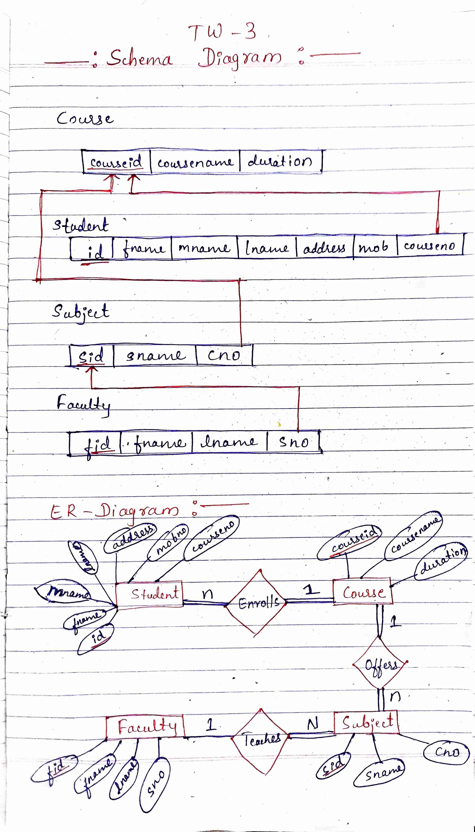

* + - 1. Create above tables by properly specifying primary and foreign keys.
      2. Insert at least 5 values to all tables.

Create table course

(

courseid number(3) primary key,

coursename varchar(30) not null,

Duration number(2) not null

);

Insert into course values(111,'BCA',52);

Insert into course values(112,'BSC Computer Science',50);

Insert into course values(113,'BSC Chemistry',48);

Insert into course values(114,'BSC Physics',50);

Insert into course values(115,'BBA',48);

Insert into course values(116,'BFT',42);

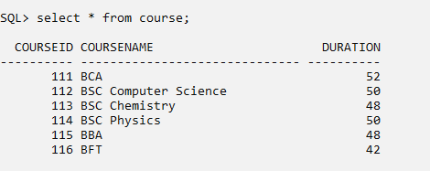

create table students

(

id number(3) primary key,

fname varchar(10) not null,

Mname varchar(10),

Lname varchar(10),

Address varchar(30),

Mobile number(10),

courseno number(3),

check(length(Mobile)=10),

foreign key (courseno) references course(courseid)

);

Insert into students values(1,'Vinay','B','Sharma','Belagavi',8956237412,111);

Insert into students values(2,'Roopa','V','Savant','Belagavi',9875237412,112);

Insert into students values(3,'Murnal','P','Jede','Bailhongal',9986237412,111);

Insert into students values(4,'Deepak','B','Kumar','Belagavi',4566237412,112);

Insert into students values(5,'Prreti','K','Patil','Belagavi',8956237678,113);

Insert into students values(6,'Sheetal','R','Hasan','Khanapur',8886237412,113);

Insert into students values(7,'John','E','Mendonsa','Belagavi',9956237412,112);

Insert into students values(8,'Bipin','C','Rana','Bailhongal',5656237412,114);

Insert into students values(9,'Manoj','B','Kumar','Belagavi',7776237412,114);

Insert into students values(10,'Anjali','B','Vani','Khanapur',2646237412,115);

Insert into students values(11,'Mayur','B','Shaha','Belagavi',8974237412,115);

Insert into students values(12,'Sufiya','T','Shaikh','Bailhongal',9797237412,116);

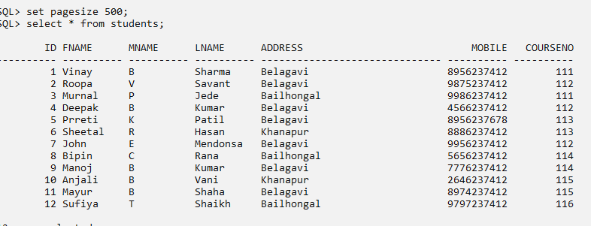

create table subjects

(

sid number primary key,

sname varchar(20) not null,

cno number(3),

foreign key (cno) references course(courseid)

);

Insert into subjects values(11,'DBMS',111);

Insert into subjects values(12,'JAVA',111);

Insert into subjects values(13,'C',112);

Insert into subjects values(14,'Excel',112);

Insert into subjects values(15,'Organic Chemistry',113);

Insert into subjects values(16,'Electromagnetc',114);

Insert into subjects values(17,'Business Analytics',115);

Insert into subjects values(18,'Statistical Methods',115);

Insert into subjects values(19,'Fashion Forecasting',116);

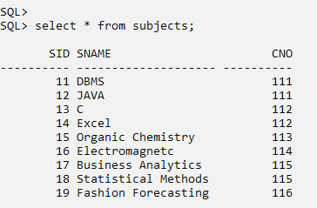

create table faculty

(

fid number(4) ,

Fname varchar(10) not null,

Lname varchar(10),

sno number(3),

primary key(fid,sno),

foreign key(sno) references subjects(sid)

);

insert into faculty values(201,'Sheetal','Soni',11);

insert into faculty values(201,'Sheetal','Soni',12);

insert into faculty values(202,'Swarali','Joshi',11);

insert into faculty values(203,'Manisha','Rawoot',13);

insert into faculty values(204,'Nirajan','D',17);

insert into faculty values(205,'Padma','M',17);

insert into faculty values(206,'Roopa','S',16);

insert into faculty values(205,'Padma','M',15);

insert into faculty values(206,'Roopa','M',14);

insert into faculty values(207,'Sohan','R',18);

insert into faculty values(208,'Harish','M',19);

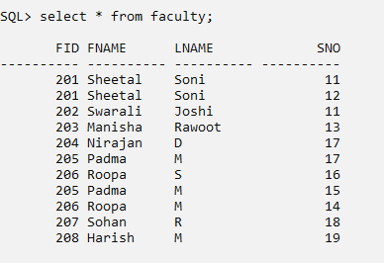

1. Find Courses starts from BSC.

select * from course where coursename like'BSC%';

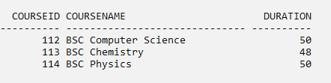

1. Display Student name and his/her course

select Fname,lname ,coursename

from students,course

where course.courseid= students.courseno;

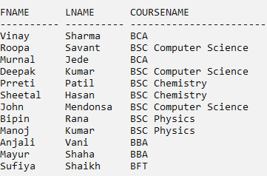

1. Which subject is handled by Faculty Sheetal Soni?

select sname from

faculty,subjects

where subjects.sid=faculty.sno and fname='Sheetal' and Lname='Soni';

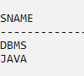

1. . Find Faculties name, subjects teaches for BCA.

select fname,lname,sname

from course,subjects,faculty

where

course.courseid=subjects.cno and subjects.sid=faculty.sno and coursename='BCA';

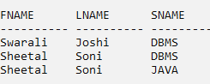

1. Display the subjects with its course.

select sname,coursename from subjects,course where course.courseid=subjects.cno;

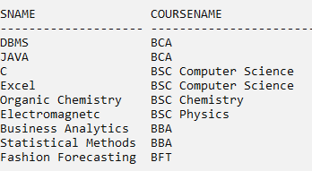

1. Count number of students course wise.

select coursename,count(*) as No_of_Students

from course,students

where course.courseid= students.courseno

group by coursename;

